
Company
Logotype

Cone Beam Computed Tomography- Report



Porur Dental X-rays & CBCT

Patient Name : Mrs. Prakalya | Date of Report : 10.07.2024
Age/ Gender : 31 years/ Female | Region of Interest : CBCT Mandible
Referring doctor: Dr. Supriya | Indication : Implant assessment
Clinical Notes: Nil
PATIENT INFORMATION

CBCT- Mandible provided
CBCT – IMAGE DETAILS

RADIOGRAPHIC INTERPRETATION

- Completely missing crown and root portion in relation to 36, 37, 38, 47.
- In relation to 45, presence of restorative material in relation to the pulp canal extending upto the apical third of the roots is evident. In relation to its apical region, presence of diffuse hypodensity measuring 3.44 x 4.21 x 3. 34 mm is evident with diffuse borders.
- In 46 region, presence of hyperdense crown structure is evident.
- The alveolar bone in relation to the mandible is present with normal trabecular pattern.

IMPLANT ASSESSMENT

 | 36 region | 37 region
Sub-Crestal (in mm) | 6.78 | 9.37
Mid- Crestal (in mm) | 9.22 | 11.67
Distance between alveolar ridge and the inferior alveolar nerve canal (in mm) | 16.28 | 15.69
Distance between alveolar ridge and the inferior border of mandible (in mm) | 27.34 | 23.68

RADIOGRAPHIC IMPRESSION

- Partially edentulous region: 36, 37, 38, 47.
- Root canal treated: 45.
- Crown in relation to 45, 46.

Kindly correlate with clinical findings


IMAGES FOR REFERENCE

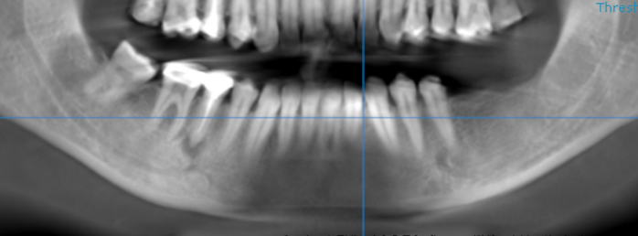
RECONSTRUCTEDPANORAMIC VIEW

3-DIMENSIONAL VIEW
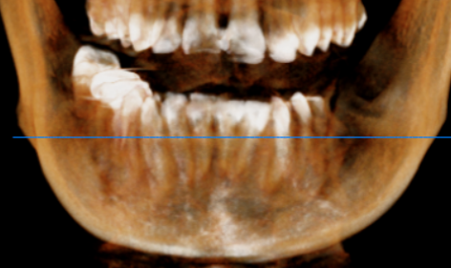

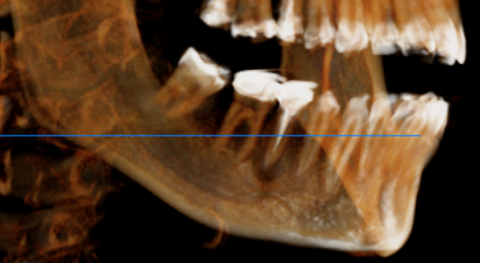
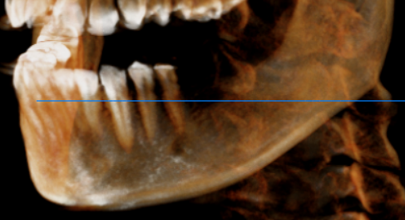

CROSS SECTIONAL VIEW

36 region | 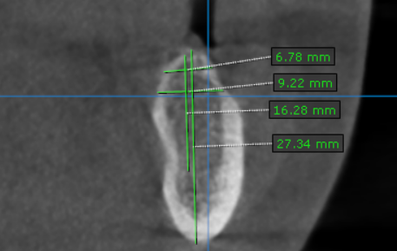
37 region | 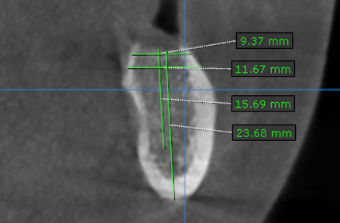

**** End of report ****

